**Learning Flux Balance Analysis from a toy metabolic model**

***Please, answer to the following questions, and write your answer below each point.***

1. What is the main assumption of FBA?  
   The system is in steady state: for each metabolite, sum if input fluxes = sum of output fluxes
2. What are the 3 inputs required to perform FBA of a metabolic network?   
   - stoichiometric matrix  
   -reaction constraints  
   -optimization function

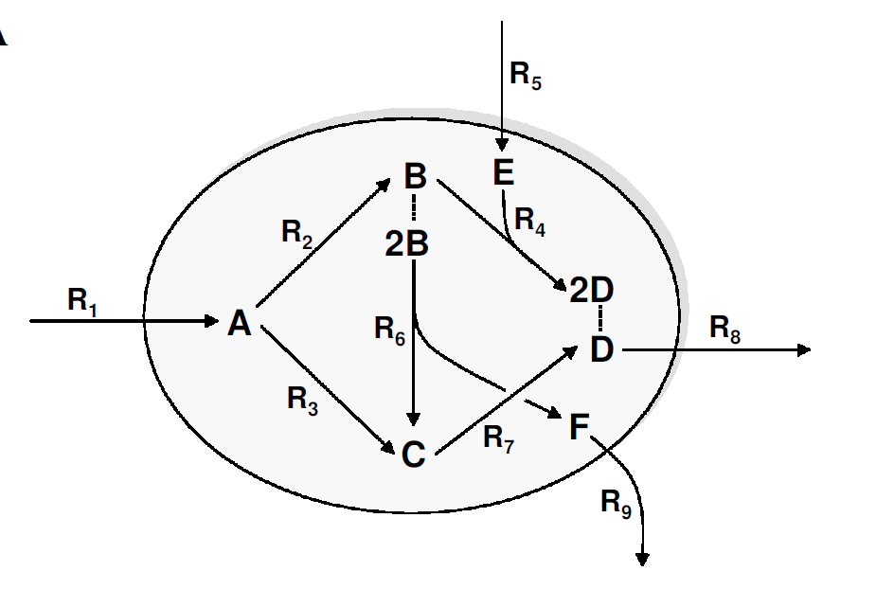

1. (Pen and paper) The above toy metabolic network contains 9 irreversible reactions. The enzyme capacities of reactions R1 and R5 are limited to a maximum of 10 mmol/gDW*h-1 each, while the other reactions are not limited.
   1. We assume that the resources (R1 and R5) are given, and the cell maximizes the extracellular production of the metabolite D (R8). What will be the optimal distribution of fluxes in this case?  
      The optimal use of resources would channel the flux through R1-R2-R4-R8
   2. What changes will happen if the metabolite E disappears from the environment?  
      Reaction R4 cannot take place, forcing a different distribution of optimal fluxes: R1-R3-R7
   3. The simulated organism is evolved to maximize the production of metabolite D. If you are doing metabolic engineering in the lab, what can you do to force this organism to also produce metabolite F?  
      You could knockout/inhibit the enzyme catalyzing R3 and eliminate compound E from the medium
   4. How will the production of metabolite D change if the rate of the enzyme catalyzing reaction 5 is halved?  
      From optimal 20 mmol/gDW*h-1 it goes down to 15.
2. (Pen and paper) Write the stoichiometric matrix of this model. Each row corresponds to a metabolite; each column corresponds to a reaction.  
   S=[ 1 -1 -1 0 0 0 0 0 0

0 1 0 -1 0 -2 0 0 0

0 0 1 0 0 1 -1 0 0

0 0 0 2 0 0 1 -1 0

0 0 0 -1 1 0 0 0 0

0 0 0 0 0 1 0 0 -1];

1. Now you will simulate the toy model in MatLab. The script ToyFBA.m is already prepared to help you perform the following tasks. Please, read the comments in the file and try to understand the meaning of the variables: S, lb, ub, obj. Edit the file by defining the values for these four variables according to the model in 4.
2. Run the script ToyFBA.m to solve the optimization problems defined in 4a, 4b, 4c and 4d*. Compare the resulting flux distributions with the distributions you predicted manually in exercise 4. In case of differences, who did a better job in finding the optimal solution?

*Hint: you have to change the upper bounds of reactions accordingly.   
The only parameter to be changed to simulate the different scenarios are the upper bounds (ub variable in the script):

ub=[10;1000;1000;1000;10;1000;1000;1000;1000];

ub=[10;1000;1000;1000;0;1000;1000;1000;1000];

ub=[10;1000;0;1000;0;1000;1000;1000;1000];

ub=[10;1000;1000;1000;5;1000;1000;1000;1000];

1. In order to resemble a more realistic metabolic model let’s assume that R1 is a glucose transporter, R5 takes up oxygen and R9 secretes succinate. Now, imagine that you have performed an experiment and measured physiological parameters of the microorganism:   
   glucose uptake (R1) = 10 mmol/gDW*h-1,  
   oxygen consumption (R5) = 0 mmol/gDW*h-1   
   and growth rate (R8) = 5 mmol/gDW*h-1 .

You immediately realize that the FBA prediction does not match your experimental data.  
How could you constrain the FBA model so that it fits the experimental data? What are the effects of using these new constraints and how would you validate the new predictions made by FBA?   
It looks like the system is not using R3 to catabolize glucose, rather it uses R6 at the cost of wasting carbon via F secretion. By deleting R3 (upper bound =0) your optimal flux distribution will mimic your experimental data. To validate model based predictions, the easiest solution would be to measure secretion of F.

1. Let’s now assume that glucose uptake is performed by an active glucose pump. To import one molecule of glucose, the pump needs to hydrolyze one ATP molecule.
2. Can we introduce only one modification to the model, ATP consumption by the reaction R1? If not, what is necessary in order to simulate the model and why?  
   The model always need to be balanced. When adding ATP as a compound you need to make sure to have production of ATP to counterbalance its consumption.
3. Modify the model in order to account for ATP consumption. (For example, e.g reaction RX produces x molecules of ATP).  
   Perform again point 4 using the new expanded model.  
   One possibility is to couple R2 with production of ATP, and R1 with its consumption.
4. Are you able to achieve the same rate as in point 4? If not, what are the differences? Try to explain for each scenario why there is a change in maximal rate if this happens.  
   The outcome depends on which reactions is coupled to ATP production. If you couple ATP production with R3, regardless of the presence or absence of oxygen (i.e. compound E) the system will run the lower branch of the pathway, resulting in a suboptimal production of D.
5. Let’s consider that this toy model represents a simple micro-organism. In order to produce one unit of dry biomass, the cell needs to synthesize 1.5 units of C and 3 units of D (use the expanded model of point 8)
6. Simulate optimization of biomass production.   
   Here you need to expand the Stoichiometric model adding a column corresponding to the new “flux”: biomass production.

S=[1 -1 -1 0 0 0 0 0 0 0

0 1 0 -1 0 -2 0 0 0 0

0 0 1 0 0 1 -1 0 0 -1.5

0 0 0 2 0 0 1 -1 0 -3

0 0 0 -1 1 0 0 0 0 0

0 0 0 0 0 1 0 0 -1 0

] ;

1. What kind of modifications of the network would be lethal for the microorganism?   
   Any that would prevent the formation of C or D
2. Is there more than one possibility to kill the microorganism?  
   Remember you can delete multiple enzymes at once. For example, those catalyzing reaction R2 and R3